Tree Monitoring Policy

INTRODUCTION

Our churchyard trees are an important part of the character and history of our church.

It is important to ensure as far as possible that our trees pose no danger to public safety and do not endanger church property or neighbouring properties.

Our PCC has adopted the “Church Guidance Note on Trees”¹ from Ecclesiastical Insurance in order to provide diligent monitoring and maintenance of our trees. The remainder of this document provides the detail of requirements on us from this guidance note.

The legal obligations, against which the guidance note has been created, are available from the UK Gov HSE Website “Management of the Risk from Falling Trees or Branches”².

Diagrams showing the extent of our church grounds and boundaries are shown in Appendix 1.

TREE ZONES

We identify two tree zones for our churchyard.

Zone 1 has regular public/private access and/or is close to property of value, whether Church property or neighbouring property. This includes the public footpath through our churchyard, the area adjacent to the highway, the area close to the church itself, and the boundaries with neighbouring houses where the trees are close to buildings or where the neighbours are known to visit regularly.

Zone 2 has less frequent access and is away from any property of significant value. This comprises the remainder of the churchyard and the woodland area in the north of the grounds.

Diagram A shows the Zones and the position of significant trees in Zone 1, whilst also indicating if the tree is suspected to be jointly owned due to the trunk straddling a boundary “J”.

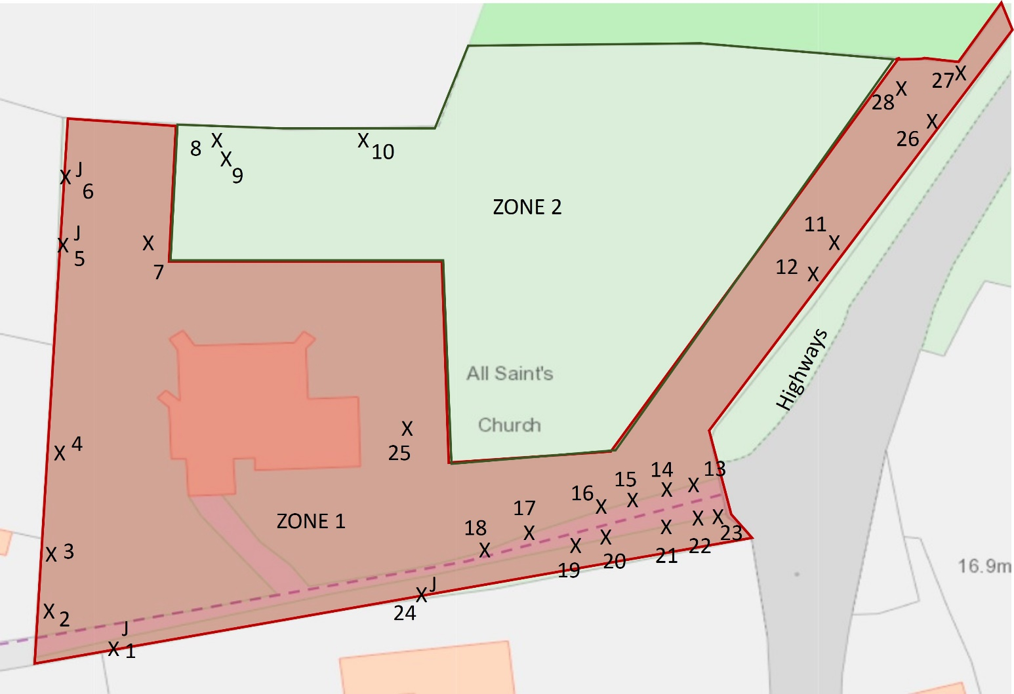
DIAGRAM A – tree zones

Significantly tall trees in Zone 1 are numbered for reporting purposes. Three trees are also numbered in Zone 2 due to their size and closer vicinity to Zone 1.

TREE MONITORING AND CORRECTIVE MAINTENANCE

Tree monitoring and maintenance will be undertaken as follows:

- The trees in each zone will be visually inspected at least every 18 months by a named person familiar with tree health and the signs of concern to look for – examples of which are summarised in “Church Guidance Note on Trees”¹

- A basic report will be produced identifying any tree of concern

- Should any tree of concern be identified that could affect a neighbouring property, the PCC will contact the owner to raise the issue and agree a way forward

- If a neighbouring tree (outside of church grounds) is thought to be of concern, the PCC will contact the owner to agree a way forward.

- A risk assessment and plan will be created for any tree of concern, which may include actions such as:

  - A Check for disease by DEFRA using samples/analysis
  - Regular formal inspection by a qualified arborist
  - Corrective surgery (e.g. branch removal)
  - Felling
  - Taping off of an area and signage to prevent access until work is possible

Details will vary from tree to tree depending on the Zone, the condition of the tree and any specific risks presented.

- Apart from simple maintenance tasks (such as basic pruning in easy reach), any tree works must be carried out by a competent arborist who will be responsible for their own risk assessment given the equipment they employ.

- The PCC will also conduct their own risk assessment of any obvious impact from proposed tree works - for example it may be best to close/tape off the churchyard during works, or seek permission from the council to temporarily close the footpath.

- Any basic maintenance by church volunteers must also be covered by a risk assessment.

A template for reporting the visual tree inspections is presented in Appendix 2.

It is also worth noting that whilst addressing the removal of dead/dangerous areas of trees does not require planning permission, it is a requirement to establish this formally first from an aborist, as every churchyard tree is protected by DAC planning rules and possibly also by Local Planning Authority rules³. A healthy tree in a churchyard cannot be felled or pruned beyond basic annual maintenance³.

TREE PROBLEM REPORTS

Should a tree problem be reported to the PCC, the PCC will react in a timely manner and a named person with knowledge of tree health will check the tree(s). The tree(s) will then be addressed as covered in the prior section “MONITORING AND MAINTENANCE OF TREES” and the person who reported the issue will be responded to appropriately.

APPENDIX 1 – Church Grounds and Boundaries

Diagram B shows the boundaries of the church grounds in relation to neighbouring properties and the highway. The church grounds are in “light green” and identified by starting at the church building and continuing in any direction until the bold grey boundary line.

Note that the footpath through the church grounds at the southern boundary is a public footpath, a designated part of the “Fynn Valley Walk”. Note also that the narrow spur at the North East of the church contains no tree trunks.

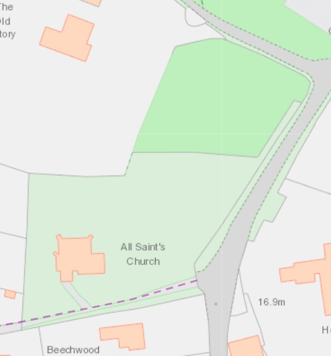
DIAGRAM B – Extent of church boundaries

Diagram C is a 2022 Google Earth satellite photo covering the church grounds in summer when the trees are in full leaf, including the general wooded area in Zone 2 the North of the churchyard.

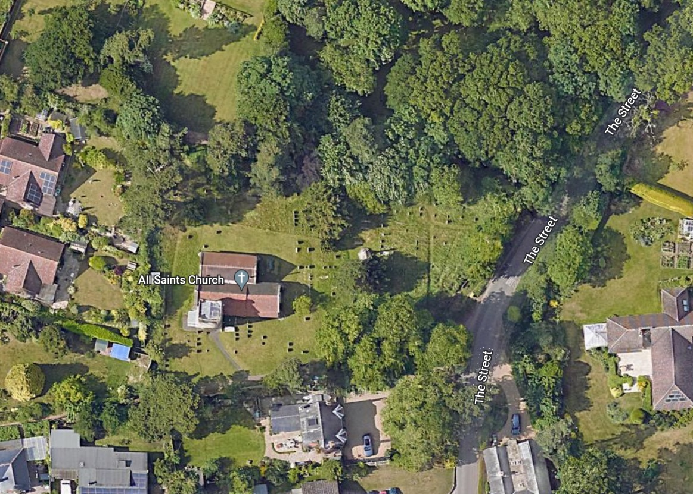
DIAGRAM C – 2022 Satellite view of Trees in Leaf

APPENDIX 2 – Reporting Template

Visual Tree Inspection - All Saints Little Bealings
Tree ID Number | Comments | Date checked
1 (J) Pine
2 Leylandii
3 Leylandii
4 Leylandii
5 (J) Pine
6 (J) Pine
7 Yew
8 Pine
9 Oak
10 Pine
11 Lime
12 Lime
13 Lime
14 Lime
15 Lime
16 Lime
17 Lime
18 Lime
19 Lime
20 Lime
21 Lime
22 Lime
23 Lime
24 (J) Pine
25 Cherry
26 Sycamore
27 Sycamore
28 Oak

REFERENCES

1. Ecclesiastical Insurance Church Guidance Note on Trees
https://www.ecclesiastical.com/documents/tree-maintenance-guidance.pdf

2. UK Gov HSE Website “Management of the Risk from Falling Trees or Branches”
https://www.hse.gov.uk/foi/internalops/sims/ag_food/010705.htm

3. Planning Rules for felling/pruning of churchyard trees. https://www.churchofengland.org/sites/default/files/2021-10/Works_to_Trees.pdf

DOCUMENT CONTROL

Policy Number | 10
Version | 1.0
Author /Origin | John Wittgreffe, Churchwarden with contributions from Francis Mutimer (churchyard maintenance).
Comment | Based on guidance from Ecclesiastical Insurance and UK Gov HSE
Date Approved  (PCC meeting date) | 26/4/2023
Authorised by | PCC secretary on behalf of PCC
Review Period | 5 Years (review period for policy, for inspection periods see policy detail)

